

**Shree Chanakya Education Society**’s

**Indira College of Commerce And Science**

Project Report On

**E-WASTE MANAGEMENT SYSTEM**

T.Y B.Sc. (Computer Science) 2018-19

Project Members

* Aniket Tikone
* Raju Yadav
* Mayur Yadav

**Acknowledgement**

We are very grateful to present the project report on **“E-waste management System”** we would like to express our explicit thanks & acknowledgement to our project guides for their kindly & timely guidance.

We are very grateful to all the faculty members from Computer Science Department especially **Kavita Dhakad & Ashish Dhoke** for giving us valuable advice, time and suggestions as far as project is concerned.

A special thanks to Dr. Janardan Pawar ( Principal, Computer Science Department) for his help and providing us ample IT Services.

We wish to record our appreciation to all our friends and others who helped us throughout the project work directly or indirectly.

***Index***

|  |  |
| --- | --- |
| **Sr. No.** | **Title** |
| **1.** | ***Introduction of the system***   * Problem Definition * Scope of the system * Advantages of the system |
| 2. | ***System Analysis***   * Requirement Analysis * H/W and S/W Requirement * Feasibility Study(Operational, Economical, Technical) * ER Diagram * Data Dictionary |
| 3. | ***System Design***   * Usecase Diagram * Class Diagram * Object Diagram * State Chart Diagram * Activity Diagram * Sequence Diagram * Collaboration Diagram * Deployment Diagram * Component Diagram |
| 4. | ***User Manual***   * Operation Instruction * Input Screens * Output Screens * Reports |
| 5. | ***Future Enhancement*** |
| 6. | ***Conclusion*** |
| 7. | ***Bibliography*** |

**Problem definition:-**

Electronicwaste or e**-**waste describes discarded electrical or electronic devices. Used electronics which are destined for reuse, resale, salvage, recycling, or disposal are also considered e-waste. Informal processing of e-waste in developing countries can lead to adverse human health effects and environmental pollution.

Electronic scrap components, such as CPUs, contain potentially harmful materials such as lead, cadmium, beryllium, or brominated flame retardants. Recycling and disposal of e-waste may involve significant risk to health of workers and communities in developed countries and great care must be taken to avoid unsafe exposure in recycling operations and leaking of materials such as heavy metals from landfills and incinerator ashes.

**Scope of system:-**

The scope of the project is to provide approaches and strategies which have proved to be the suitable when assessing the e-waste system of the defined region. This collection will reduce the e-waste from the household, company, industries, city, etc. The Environment pollution will reduce and the electronic waste will recycle or deployed. The fundamental aims of the Basel Convention are the control and reduction of Trans boundary movements of hazardous and other wastes including the prevention and minimization of their generation, the environmentally sound management of such wastes and the active promotion of the transfer and technologies.

This technique could eliminate waste disposal costs. Reduce raw material costs and provide income from a salable waste. Waste can be recovered on-site, or at an off-site recovery facility, or through inter industry exchange.

**The advantages of the system are:**

* To provide anytime anyplace service for the customer.
* To reuse electronic waste material by recycling or deploy.
* To decrease the electronic waste material from household.
* To provide awareness about electrical and electronic material using for household.

**The disadvantages of the existing system are:**

* More man power.
* Time consuming.

**Requirement Analysis:-**

**Hardware** **requirement**:-

|  |  |
| --- | --- |
| Processor | Intel core i3GHz or more |
| RAM | 1GB or more |
| Hard-disk | 500GB or more |
| Monitor | 15’’ CRT or LCD monitor |
| Keyboard | Normal |
| Mouse | Compatible mouse |

**Software requirement:-**

|  |  |
| --- | --- |
| Front End | HTML,CSS |
| Database | PostgresSQL |
| Operating System | Windows, Linux |
| Back End | JSP |

**Feasibility study:**

Feasibility study is useful to evaluate the cost and benefit of the system requested.

This is nothing but a test, which is conducted on the proposed system, how the requirements are achieved.it is also used to understand the scope.the feasibility study tries to anticipate future scenario of software development.

At this stage, the analyst estimates the urgency of the project and estimate the development cost.

There are three major aspects in feasibility study:

1. Technical feasibility

2. Economic feasibility

3. Operational feasibility

**Technical feasibility:**

Technical feasibility involves collection of e-waste to establish the technical capability of the system being created to accomplish all requirement to the user. Technical feasibility is concerned with the availability of hardware and software required for development of system, to see compatibility and maturity of the technology proposed to be used and to see the availability required the technical manpower to develop the system.

After the study, we came to a conclusion that we proceed further with the tool and development environment chosen by us.

**Economic feasibility:-**

Economic feasibility considers the cost benefits analysis of the proposed system. The benefits are always accepted to be overweighting the cost. Economic feasibility is helpful to find the system development cost hence and checks whether it is justifiable for that it concentrate on.

1. Investigation cost.

2. Software and hardware cost.

3. Salaries and maintenance cost.

4. Supply cost.

The proposed system requires minimum hardware and maintenance cost.

Hence it is economic feasibility.

**Operational feasibility:-**

It consider the acceptability of the system.it checks whether system will be used if it developed and implemented .it checks whether the users of the system will be able to handle as if the proposed system does not create any problems.

The proposed system will be easy to handle as the overview is according to the requirement of the user. It reduces extra workload of the user proving to be beneficial. Hence the proposed system is operationally feasible.

**Entity-Relationship Diagram:-**



**Data dictionary:-**

**Admin:-**

|  |  |  |
| --- | --- | --- |
| fname | Varchar(20) |  |
| lname | Varchar(20) |  |
| add | Varchar(20) |  |
| mobnum | numeric |  |
| username | text | Unique |
| password | text | Not null |

**Customer:-**

|  |  |  |
| --- | --- | --- |
| fname | username |  |
| lname | Varchar(20) |  |
| add | Varchar(20) |  |
| mobnum | numeric |  |
| username | text | Unique |
| password | text | Not null |

**Waste:-**

|  |  |  |
| --- | --- | --- |
| wname | Varchar(20) |  |
| wcondition | Varchar(20) |  |
| wweight | int |  |
| wqnt | numeric |  |
| wid | int |  |
| username | Varchar(20) | Foreign key |

**Sell:-**

|  |  |  |
| --- | --- | --- |
| sdevice | text | Not null |
| scompany | Varchar(20) |  |
| price | int | Not null |

**Usersell:-**

|  |  |  |
| --- | --- | --- |
| username | text | Foreign key |
| sdevice | text | Foreign key |

**System design:-**

**Usecase diagram:-**



**Class diagram:-**



**Object diagram:-**



**State chart diagram for admin :-**



**State chart diagram for customer :-**



**Activity diagram for admin :-**



**Activity diagram for customer :-**



**Sequence diagram for customer:-**



**Sequence diagram for admin:-**

**Collaboration diagram:-**



**Deployment diagram:-**



**Component diagram:-**



***User Manual***

**Operational Instructions:-**

Admin and Users can access the system.

Steps for Admin:-

* Login as a admin.
* After login successfully Menu page will be displayed there will be various menus as follows:-
* View User Information
* Add Products For Selling
* View User Cart Details By Name
* View User Donation Details By Name
* Logout
* Admin can add a new recycled products for selling
* Admin can view all information of an user
* Admin can view information of user donation by his name
* Admin can view information of products which is bought by users by its name

Steps for User:-

* User has to login the system by giving his/her details as user-id and password.
* After that there will be two options for user that is 1st will be Donate option and 2nd will be Buy from us option.
* If user wants to donate his/her E-waste he can click on 1st option that is Donate.
* After Clicking on donate option a new page will open which includes fields like Waste name, its weight, quantity ,and its condition .
* After submitting E-waste information a new page will open which includes Thank you message and three more options which are Donate More, Buy From Us and LogOut
* If user wants to buy from us then he will click on 2nd option which is Buyer
* After clicking on that option a new page will open which includes cart list from which we can select multiple products which is to be buy after add to cart option a total cost of all products which is selected to buy will be shown which has to pay at the time of delivery.

User has to logout the system after performing these two operations.

***Input Output Screens***

**About us:-**

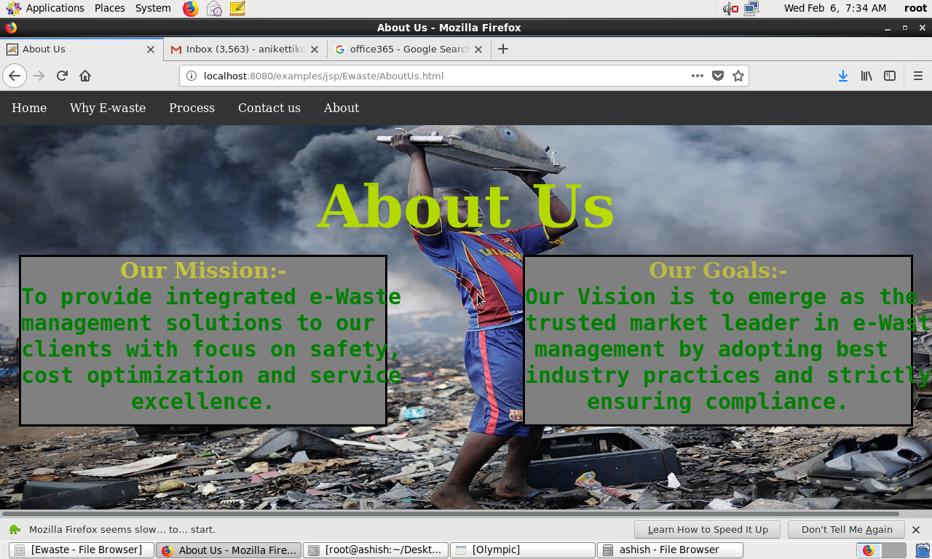

**Process flow:-**

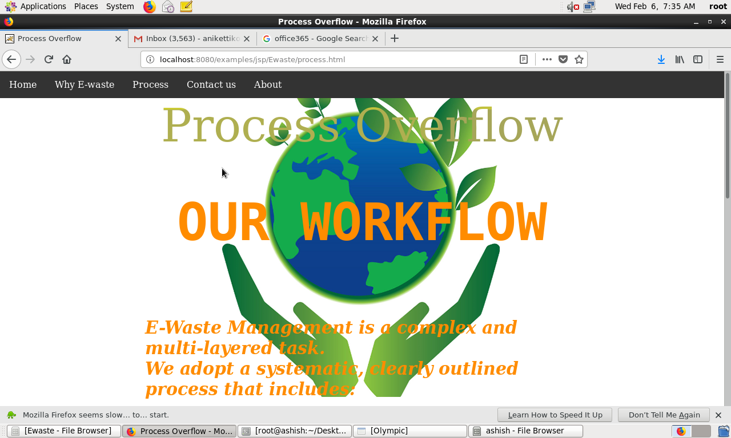

**Contact us:-**

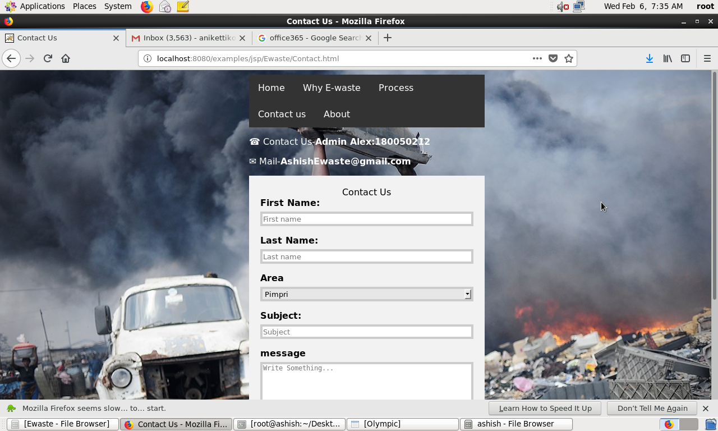

**Customer Login Page:**

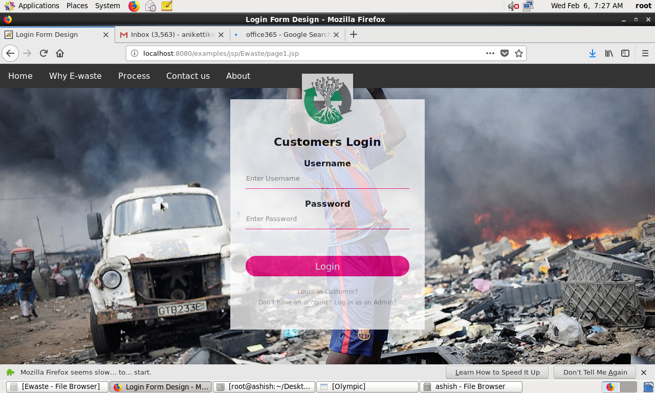

**Customer options:-**

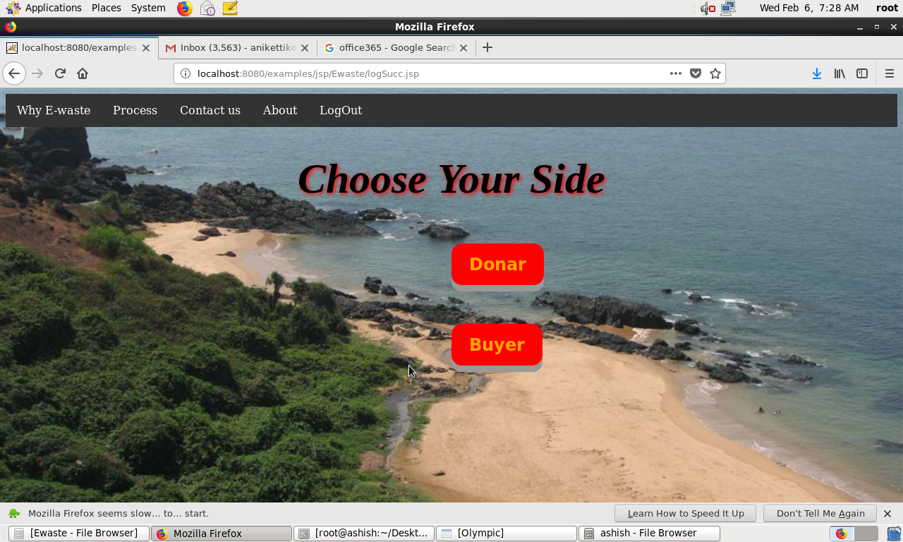

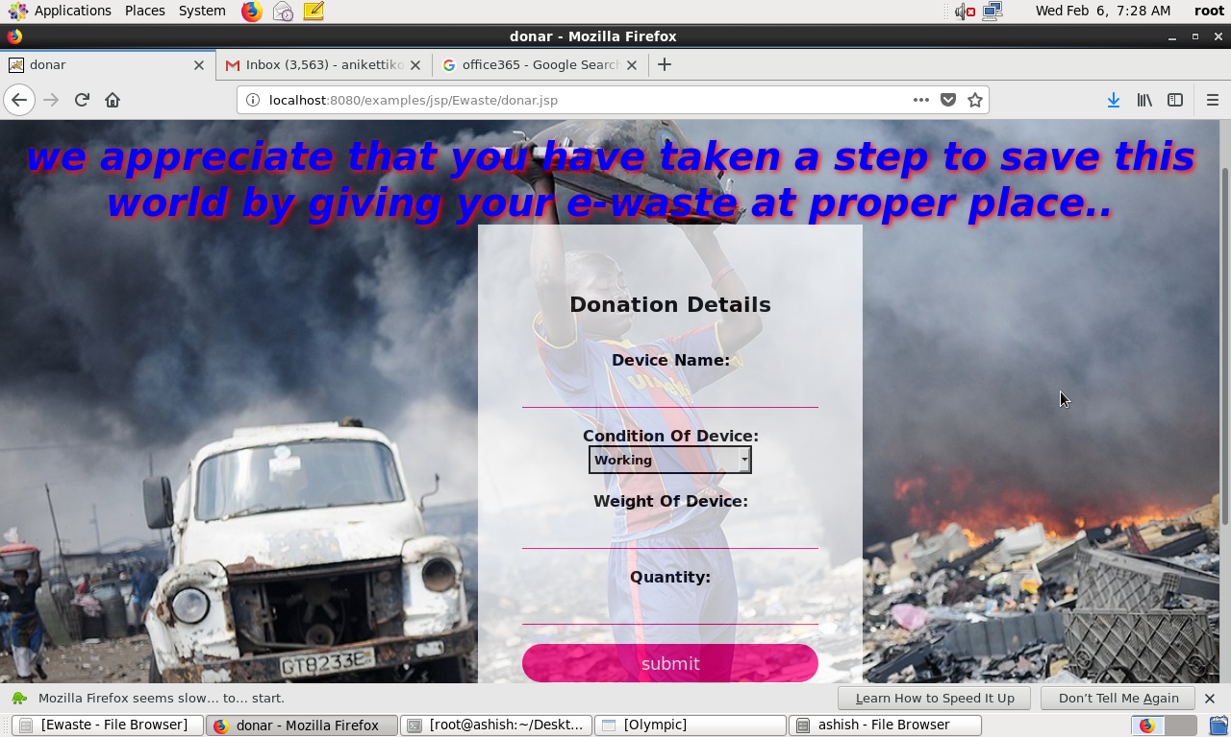

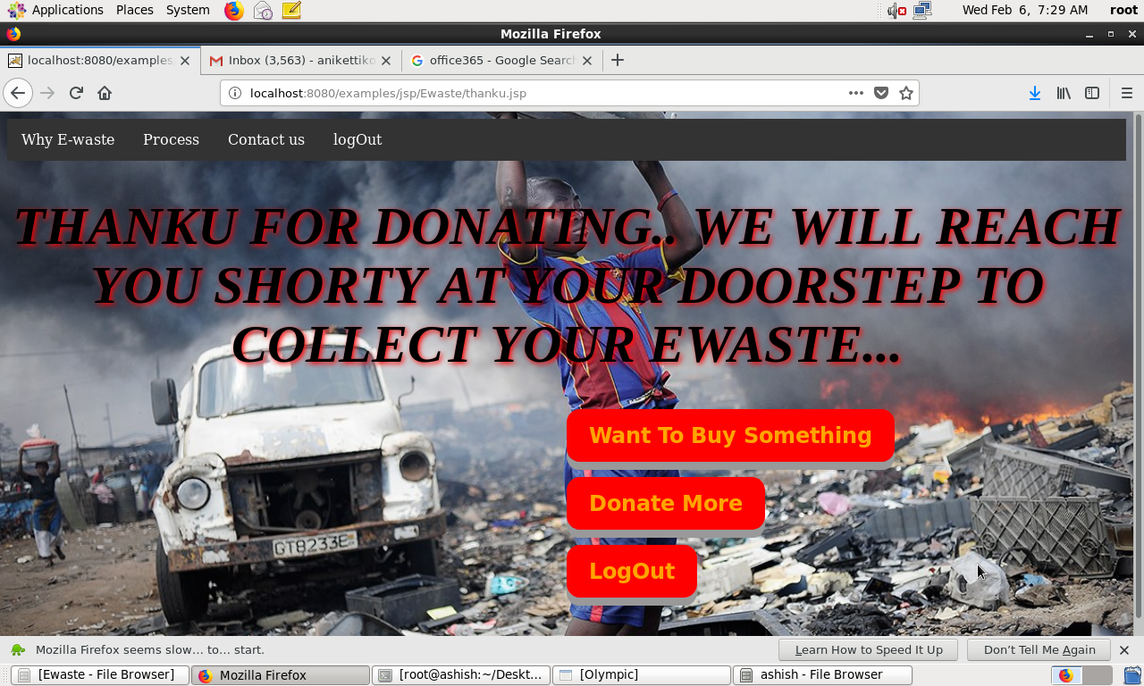

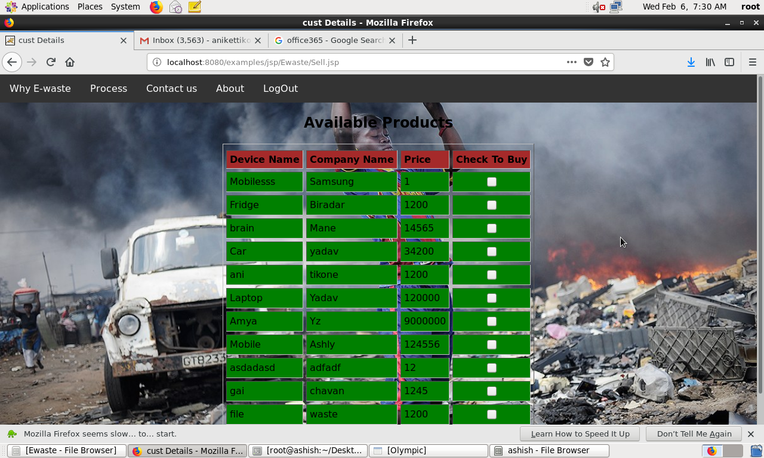

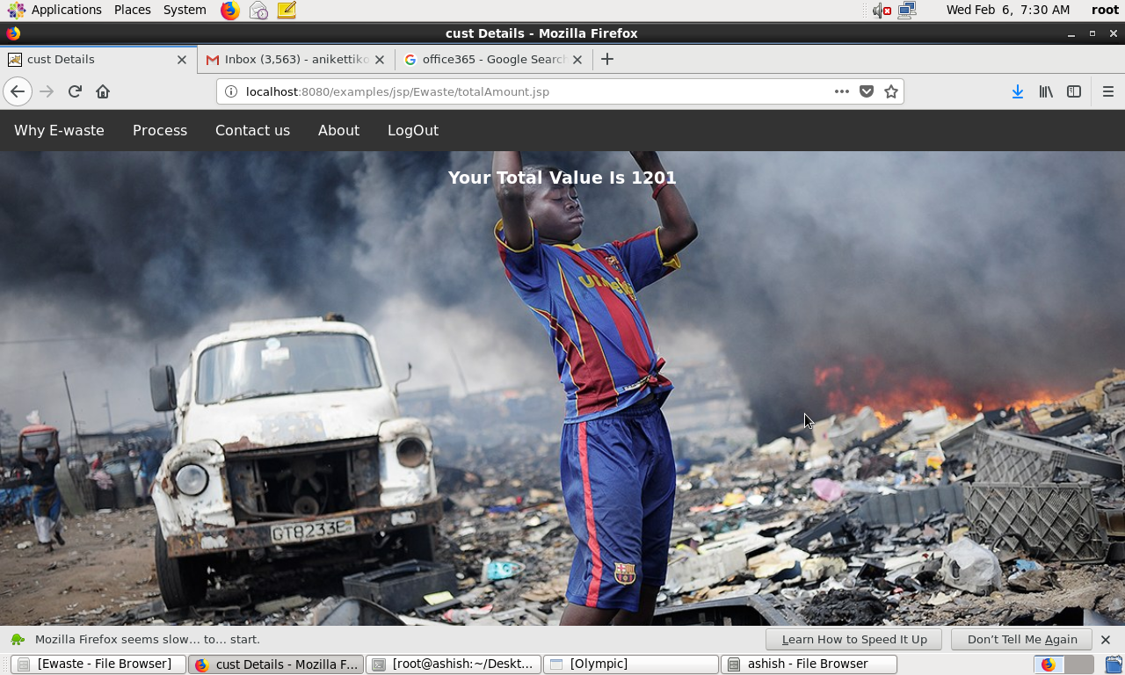

**Admin Login Page:**

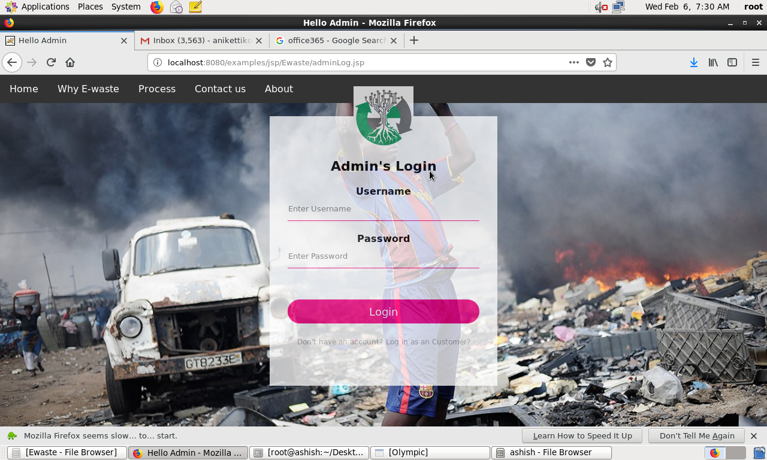

**Admin options:-**

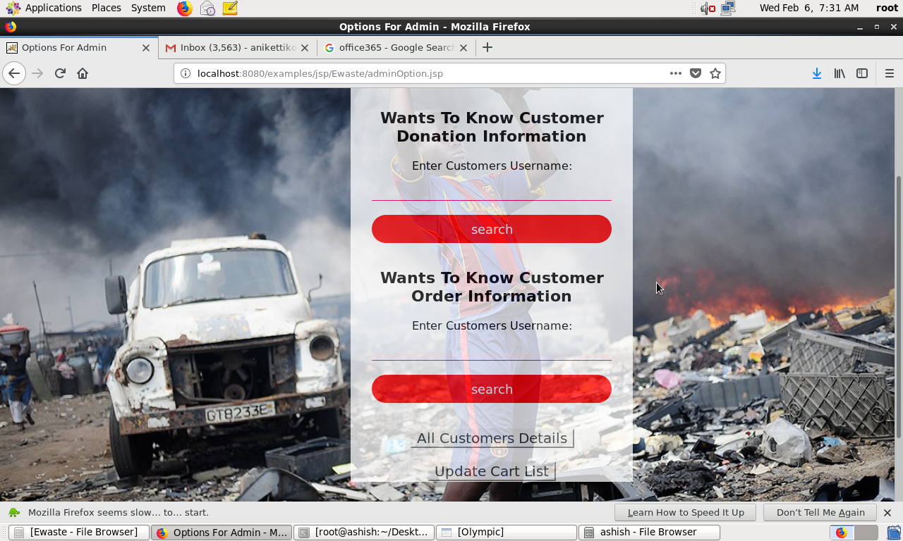

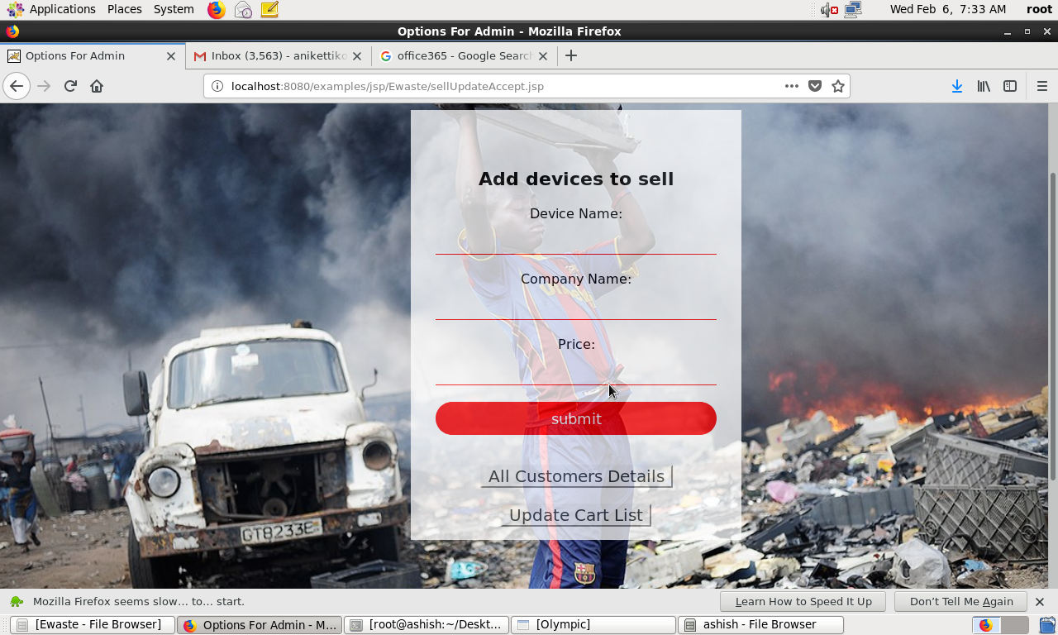

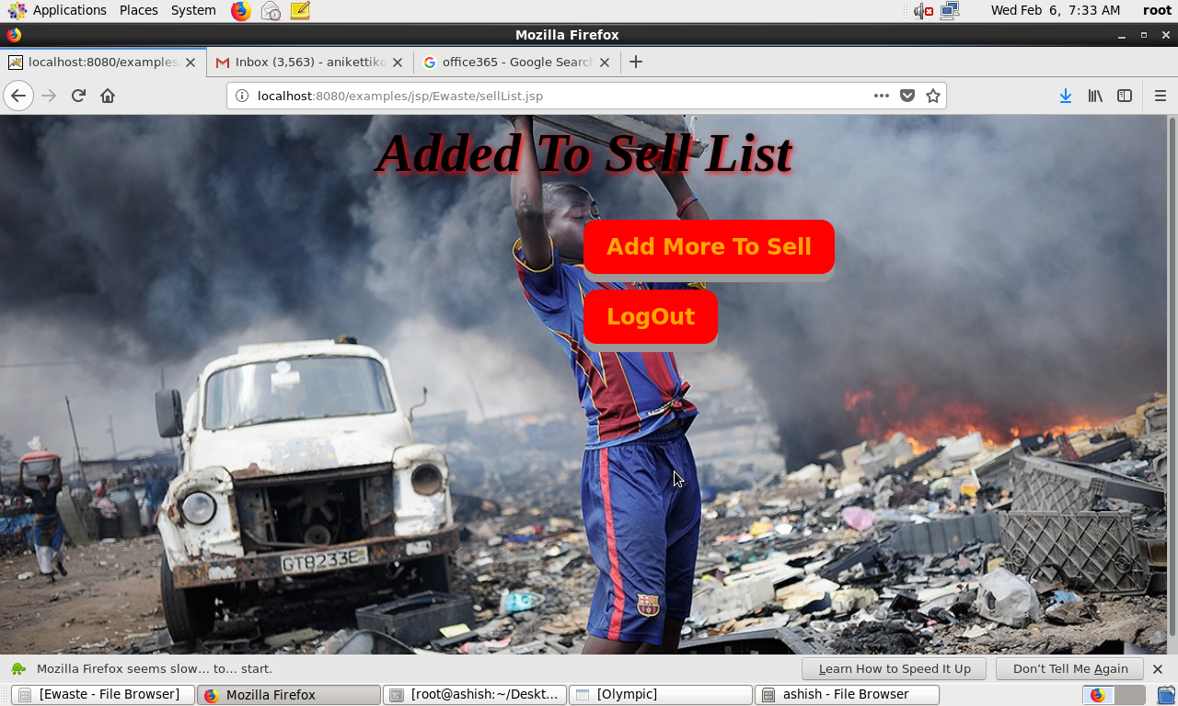

**Reports:-**

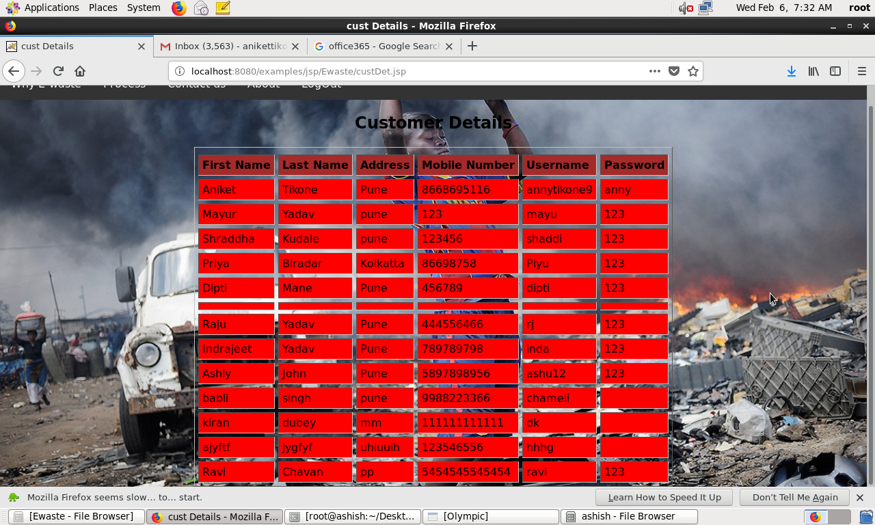

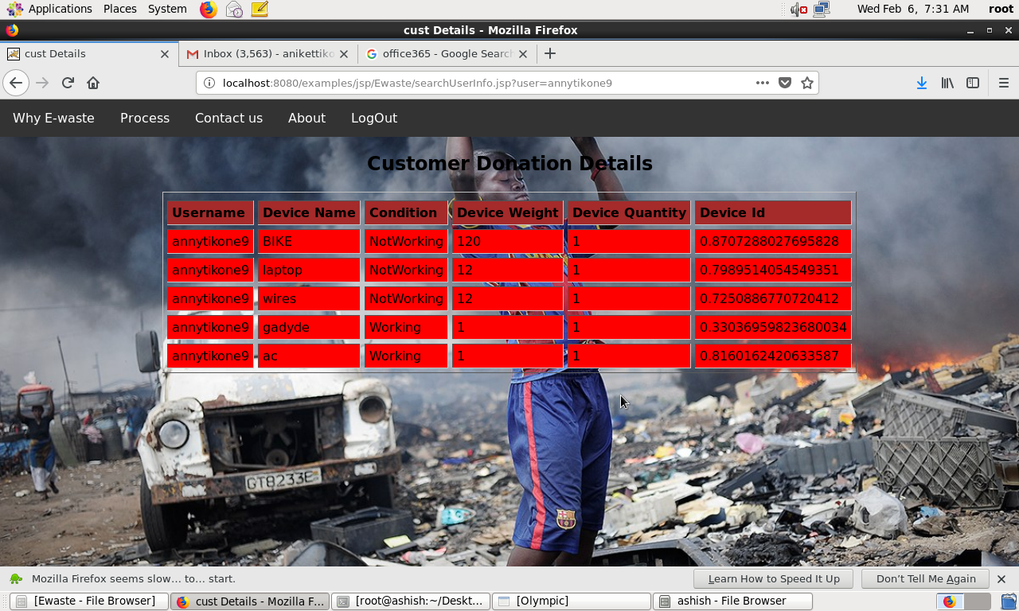

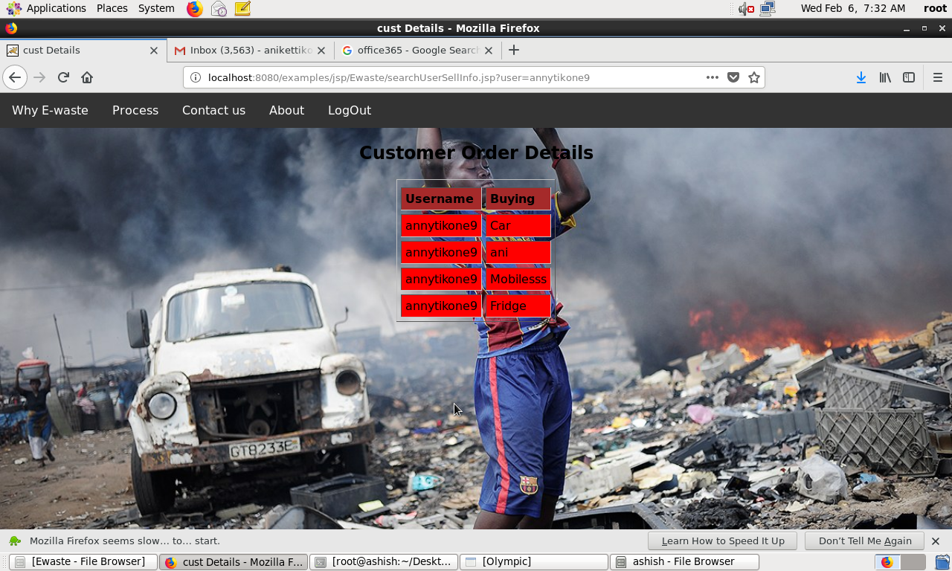

**Future Enhancement:-**

* Could the sustainable cities of the future prominently feature e-waste collection? E-waste management system is future to reduce the electronic waste and reusability of the electronic material in the future.
* The E-waste management system that develop the information and awareness about the recycling and problem affect by them collection. Decrease the electronic and electric waste from the world and less development of electronic and more recycling of the material.

**Conclusion:-**

Electronic and electrical equipment’s cannot be avoided in today’s world. So also is the case of waste Electronic and electrical equipment. As long as is a necessary evil. It has to be best managed to minimize its impacts on environment. Electronic waste piles are growing as is their pollution potential. Most of these problems have their source in the development and design of the product concerned. Using this type of system we can conclude that using methodology of reduce, reuse and recycle decrease the piles of electronic and electrical equipment, and make environment to be clean and healthy.

**Bibliography:-**

**Websites**

* [www.google.com](http://www.google.com)
* [www.w3schools.com](http://www.w3schools.com)
* [www.freeprojectz.com](http://www.freeprojectz.com)